THE STROUSE CORPORATION
CR022: MULTI IN OUT CHANGES
PROCESS FLOW DOCUMENT

Create New Strouse Multiple In Out:
Navigation: List -> Relationships -> Customers -> New
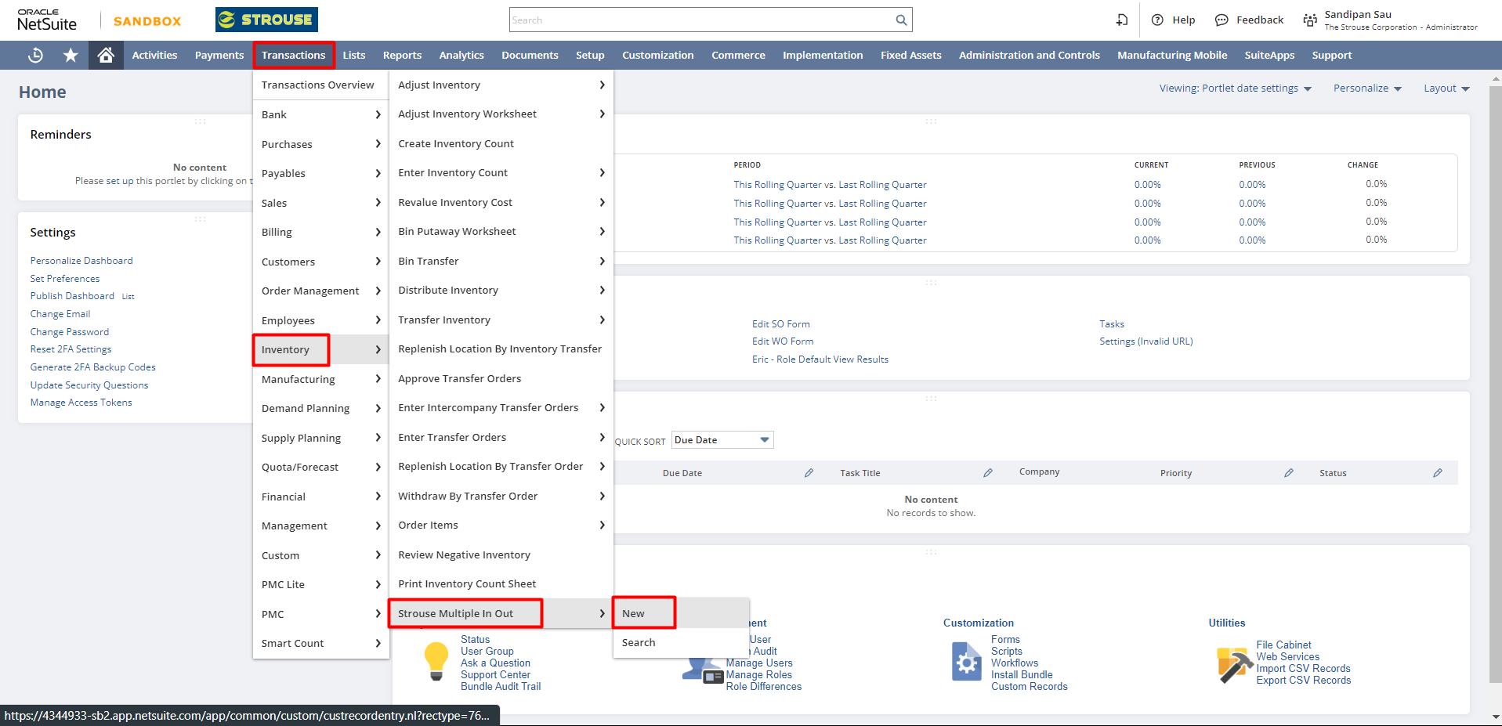
In Strouse Multiple In Out Record, fill all necessary details like Input Items, Output Items. Select the Input Items Quantity, Lot Number & Output Items Quantity. Then, click on Save.
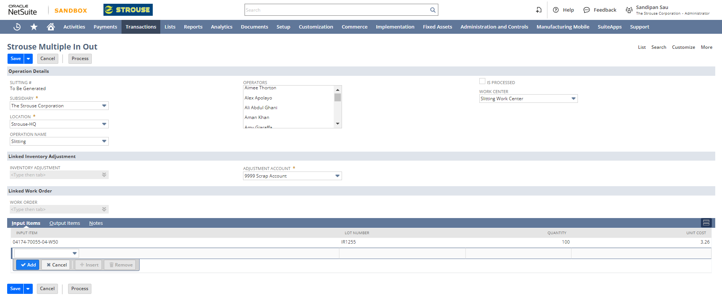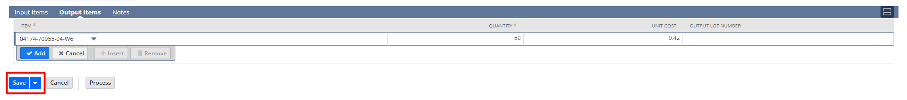

Track Labour Cost:
After saving the Multiple In Out Record, user will see the "Track Labor Cost" button.
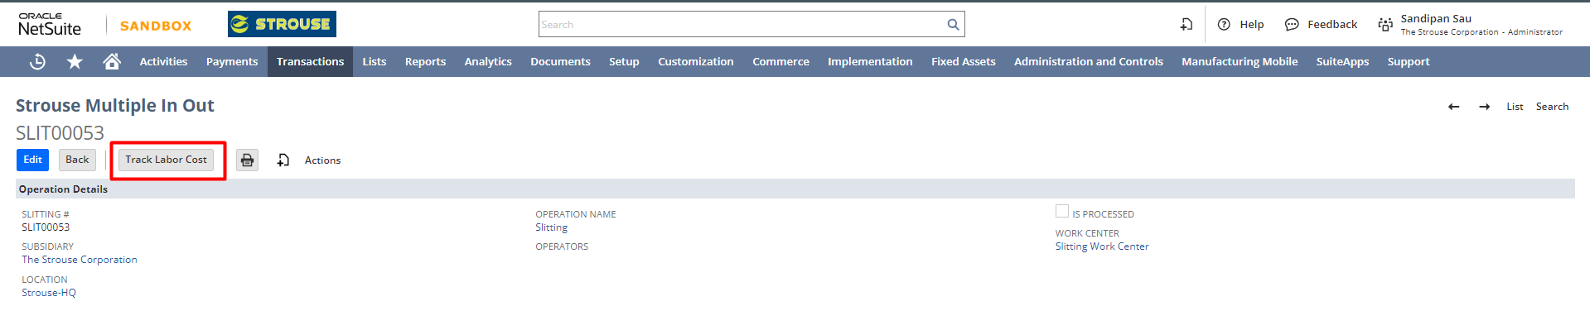
Upon clicking the "Track Labor Cost" button, the Work Order page will open. It will automatically source all the basic details such as Assembly Name (Slitting Assembly), Location, Quantity, BOM, BOM-Revision, and Routing. These details are pre-filled based on the Generic Item setup, also the Work Order Quantity will default to the Input Quantity of the Item Being Slit.
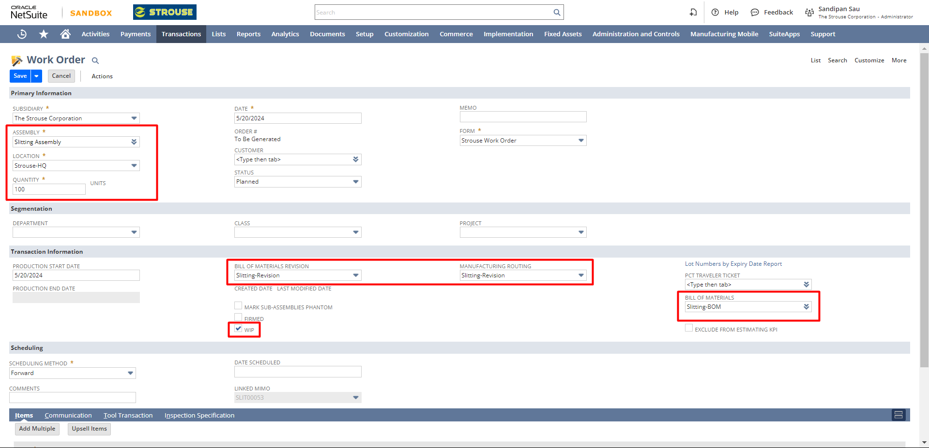
After reviewing the details, save the Work Order.
After saving the Work Order, go back to the Strouse Multiple In Out record. The newly created work order will be linked under a “Work Order” field on the Strouse Multi In-Out record, and the button for Track Labor Cost will no longer be available once the Work Order is created.
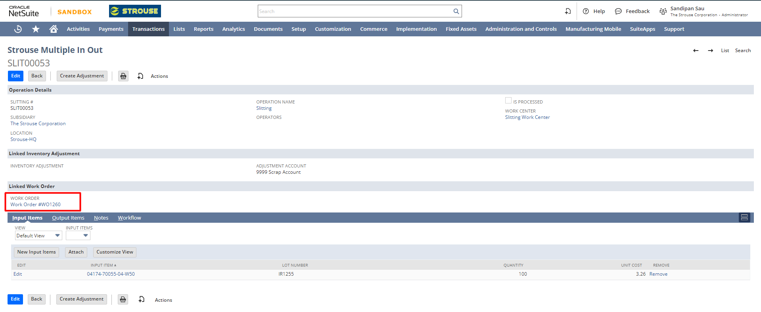
In the Work Order as well, a “Linked MIMO” field will be present to keep the track, when a Work Order is created from Multi In-Out record. If it is not created from a Multi in-out record, it will remain blank.
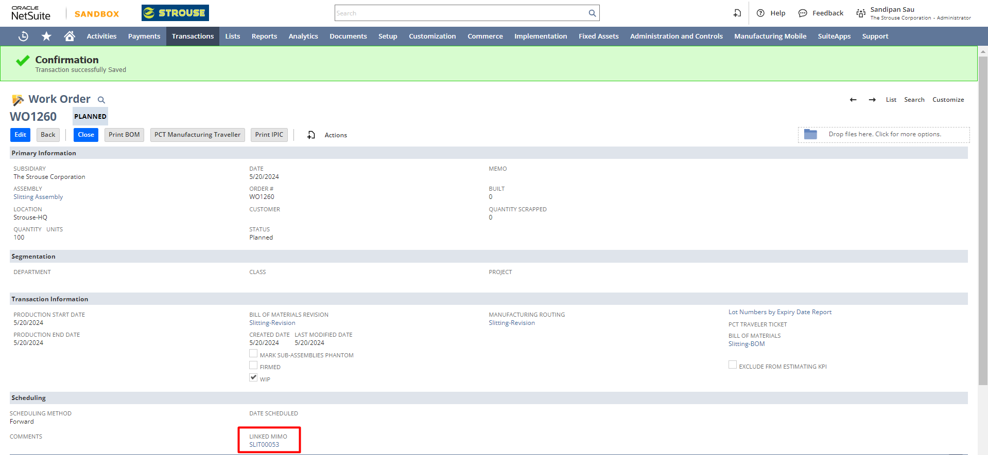
Create Completion:
User would need to create the Work Order Completion and log the time for the completed quantity during the slitting process using PMC, PMC Lite, or manual entry using NetSuite UI.
Create Adjustment:
Once the time and labor cost tracking for the slitting process is complete, user would click on the “Create Adjustment” button on the Strouse Multi-In Out. Once done, the output unit cost will be calculated as follows:
- Material Cost: Average Cost of Item X Input Quantity
- Labor Cost: Sum of Projected Value on all Work Order Completions
- Total Cost for Slitting: Material + Labor Cost
- Unit Cost for Output Item per Unit: Total Cost for Slitting/Total Output Quantity
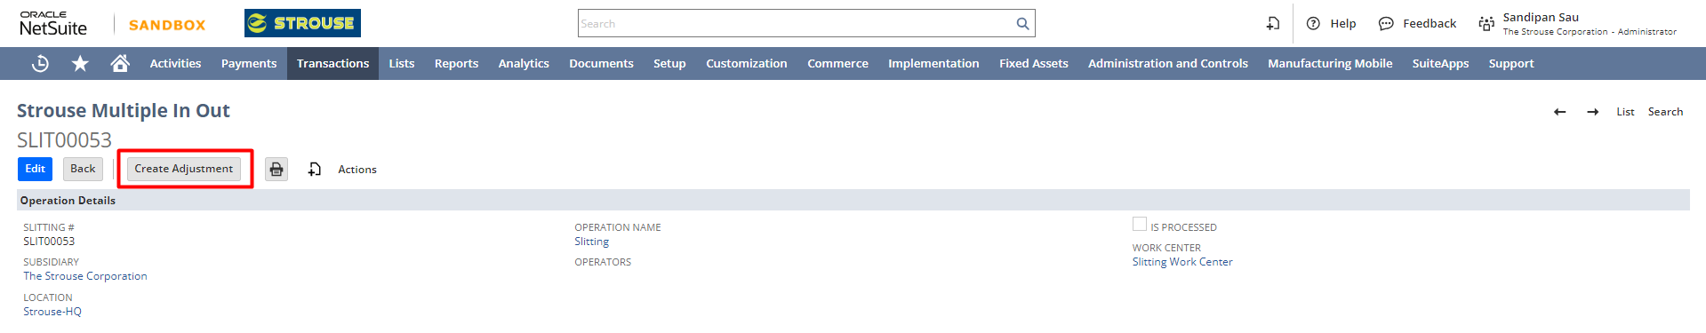
The Inventory Adjustment would be created automatically, and be linked in the “Inventory Adjustment” field. The input Item will use the Average cost, while the output item will use the unit cost calculated.
